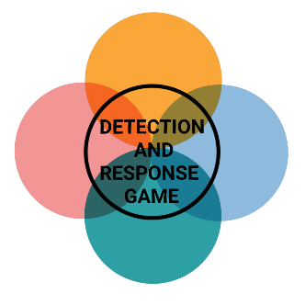

**INITIAL ACCESS**



**DEFENSE EVASION**



**PRIVILEGE ESCALATION**



**INITIAL ACCESS**

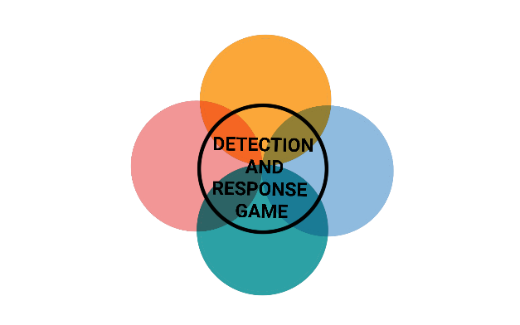

**INITIAL ACCESS**



**INITIAL ACCESS**



**INITIAL ACCESS**



**INITIAL ACCESS**



**COMMAND AND CONTROL**



**LATERAL MOVEMENT**



**DISCOVERY**



**IMPACT**

**RUNDLL32**

Ryuk abuses rundll32.exe to proxy execution malicious code on the Domain Controller.

* Signed Binary Proxy Execution
* May avoid triggering security tools because of allowlists or false positives from normal operations

**BAZAR**

Ryuk uses Bazar a malware downloader and backdoor to deploy additional malware, including ransomware and to steal sensitive data.

* Relies on user execution
* Injects malicious code into cmd, explorer, and svchost
* Creates autorun entries
* Download and execute the BazarBackdoor and Cobalt Strike beacons

**CVE-2020-1472**

Ryuk establishes a vulnerable Netlogon secure channel connection to a domain controller, using the Netlogon Remote Protocol to reset the credentials on the domain controllers.

* Unauthenticated attacker requires MS-NRPC and a TCP Connection to the DC
* Takes advantage of incorrect AES mode

**SPEARPHISHING**

Ryuk send a spear phishing email leading to a Bazar Loader malware executable.

* From SendGrid email marketing platform
* Decoy google preview page
* Certificate signing to evad anti-virus
* Downloads encrypted BazarBackdoor



**INITIAL ACCESS**



**INITIAL ACCESS**



**INITIAL ACCESS**



**INITIAL ACCESS**

**REMOTE SERVICES**

Ryuk used a valid domain administrator account to log into a service specifically designed to accept remote connections, such as telnet, SSH, and VNC to transfer data undetected.

* An executable was transferred to the DC via SMB
* RDP was used to distribute a ransomware payload enterprise wide

**RYUK EXECUTABLE**

Ryuk executes Ransomware - a type of malware that encrypts files of the victim and restores access in exchange for a ransom payment

* Lowest observed ransom was for 1.7 BTC and the highest was for 99 BTC

**ACTIVE DIRECTORY**

Ryuk used cmd, Powersell and ADFind to collect information about the Activ Directory Evironment.

* Host names
* Operating systems
* Last logon dates
* Domain Trusts
* Domain Admins
* User- und Computernames

**BAZARBACKDOOR & COBALT STRIKE**

Ryuk used Bazarbackdoor and Cobalt Strike to exfiltrate network data to several domains and to control the network.

* Report_Print.exe
* 3.137.182.114:443
* cstr3.com
* servisses.exe
* 88.119.171.94:443